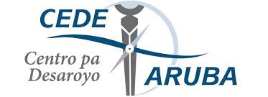
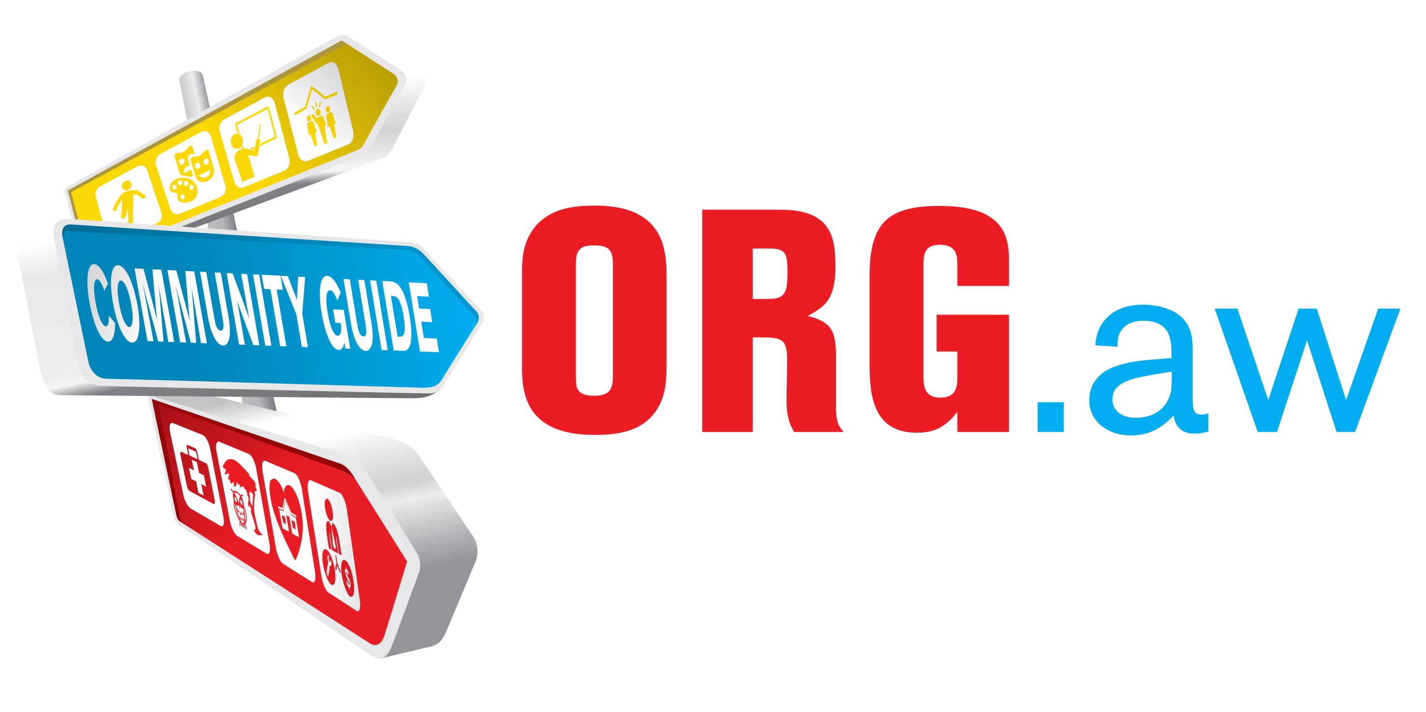
Registration form Community Guide / Guia Comunitario / Gemeenschapsgids ORG.aw
The Aruban Community Guide contains organizations that work in the areas of health & care, labor & income, sports & recreation, social support & housing, art & culture, school & education, environment & animals and neighborhood development. Is your organization active in one or more of these areas and has it not been included in the Community Guide? Please register the organization using the form below.

Registration of your organisation on ORG.aw is free the first year and it is funded by CEDE Aruba. After the first year, the cost for maintenance of the platform may be covered in various ways. Possibly CEDE Aruba will continue to bear the costs, maybe sponsors can be found or maybe a symbolic contribution will be requested from the registered organizations. This will ofcourse be discussed ahead of time with the organizations.

Why register?
- Community Guide will be the website with information about all Aruban organizations with a service for the welfare of the community
- Managed by a professional organization with knowledge of the working field and development therein
- Regular monitoring ensures that the information is up-to-date

Tips for completing the form
- The Community Guide will be in the languages English, Papiamento and Dutch. In completing the form you can use any of these 3 languages. We will translate to the other languages
- The questions marked * are mandatory
- Please note, the form has to be filled out completely in one browser session. You can not partly complete the form, close your browser or computer and finish it later
- Unless otherwise stated, the information entered here will be visible to all visitors of the Aruban Community Guide

Please send the completed form to info@org.aw
Thank you for your cooperation!
Your information
The following information is necessary so that we can contact you with any questions about the data entered.
The data entered here will NOT​ be displayed on the Community Guide website.
Your name *: Desiree Eldering
Email *: desiree@arubandonkey.org

Contact information organization
Organization name short *: DSA or FSNB
(Abbreviation name of the organization).

Organization name full *: Donkey Sanctuary Aruba or Fundacion Salba Nos Burico
(Full name of the organization).
Website name for ORG.aw : arubandonkey.org.aw
(This name will be used for your profile page on org.aw. It will look like for example: “cedearuba.org.aw”. The “Organization name short” will usually be the best choice).
Phone 1 *: 5932933
(Your main telephone number)
Phone 2 :
Fax :
Email 1 *: desiree@arubandonkey.org
Email 2 :
Your own website : www.arubandonkey.org
(If you have a website please add it here).
Your facebook page : donkey sanctuary aruba
Address *: Bringamosa 2-Z
(The organization's address. This can also be the postbox # ).
Opening hours *: every day 9am-4pm (closed January 1st.)

Contact person(s) organization
Please enter one or two contact persons if you wish to be contacted personally. Note that the contact person(s) may be contacted by visitors of the Community Guide.
Contact person first name : Desiree
(The main contactperson for the public to contact)
Contact person last name : Eldering
Contact person title : Mrs
Contact person position : managing director
Contact person phone : 5932933
(This can be the same number as the organisation's telephone number )
Contact person email : desiree@arubandonkey.org
Contact person 2 first name :
Contact person 2 last name :
Contact person 2 title : Miss Mrs Sir
Contact person 2 position :
Contact person 2 phone :
Contact person 2 email :

Type of organization
Select what features are applicable to the organization.
For optimal findability please select only the attributes that are really applicable.

Legal status *:
(Please choose the legal status of your organization)
X Foundation (stichting)
- Association (vereniging)
- Government organization
- Commercial organization
XVoluntary initiative

Select one or more sectors *:
(Please choose 1 or more sectors your organization works in)
- Art & culture
- Sports & recreation
- Enviroment & animals
- Health & care
- Neighborhood development
- Labor & income
- Social support & housing
- School & education

Select one or more targetgroups *:
(Please choose 1 or more targetgroups your organization works for )
- Children
- Youngsters
- Elderly
- Family & relationships
- People with disability
- Vulnerable groups
- Adults
- Parents

Description information organization
Please keep the descriptions relevant and concise so that visitors quickly understand what your organization is about. You can use Papiamento, English or Dutch. We’ll take care of translation to the other languages
Organization description short *: (maximum 150 characters, 2 lines)
(Describe the organization's core activities and goals in brief).
To protect and preserve the Aruban donkeys

Organization description full *:
(Official description of the organization).

The Fundacion Salba Nos Burico was founded in April 1997. The Foundation is an independent non-profit organization, working with volunteers, whose goals are:

a. Raising the consciousness of the Aruban people about their wild donkeys in general (‘the Aruban donkeys”);

b. Preventing the disappearance of the Aruban donkeys and trying to create a habitat wherein the wild donkeys can lead a normal life; to preserve the donkeys as the cultural heritage of Aruba.

c. Collecting and caring for those Aruban donkeys whose health/welfare
has been impaired by injury/sickness/abandonment/mistreatment.
We also wish to pick up all the donkeys currently on the street, to control the population and prevent them from being hit by cars.

Purpose of the organization *:
(The aim or goal of the organization)

Services & activities :
(General services & activities provided by your organization)
We take care of the donkeys in our care and where necessary we also take care of the wild donkeys on Aruba.

Affiliated with / member of :
(Umbrella or coordinating organization(s) of which you are a member or are affiliated to)

Organization keywords :
Please enter the most relevant keywords for your organization, for visitors to the Community Guide to find you easily.
Press 'enter' after each keyword
You can use Papiamento, English and/or Dutch. We will translate if necessary.
Donkeys
Save
Protect
Preserve
Volunteers

Additional information
Chamber of commerce number (KVK nummer) :
S365

Establishment date : 14-4-1997
(Date the organization was established in Aruba )

Application procedure : fill out application form for volunteers, available on website: www.arubandonkey.org
(How does one become a member or client of your organization )

Contribution / membership dues : entrance is free, all donations are welcome
(The amount one has to pay)

Additional remarks :
(Possible additional information you wish to add to your profile on the Community Guide )

Boardmembers
Boardmember information will NOT be displayed on the Community Guide.
Please copy underneath set for up to 6 boardmembers.

Boardmember first name : Ricardo
Boardmember last name : Contreras
Boardmember title : Dr ( veterinarian)
Boardmember position : member
Boardmember phone : 5939403
Boardmember email : convet@setarnet.aw

Boardmember 2 first name : Jaydee
Boardmember 2 last name : Perez
Boardmember 2 title :
Boardmember 2 position : Treasurer
Boardmember 2 phone : 5614127
Boardmember 2 email : perezjaydee@hotmail.com

Boardmember 3 first name : Ilyana
Boardmember 3 last name : Maduro
Boardmember 3 title :
Boardmember 3 position : Secretary
Boardmember 3 phone : 6413921
Boardmember 3 email : ilyanamaduro@hotmail.com

Advisor: Anton
Isaak
Advisor
7334455
antonisaak@yahoo.com
we are currently without a president, the Board is seeking also for a 2nd treasurer and 2nd secretary.

Attachments
Logo - this may also be a picture of the logo, or a picture with the name of the organization*:
(Please attach your logo in jpg/jpeg/png/bmp format )

Picture - for example your building, team or an activity *:
(Please attach a recognizable picture of your organization in jpg/jpeg/png/bmp format )

Other information (PDF) (max. 5MB) :
(If you wish to display your flyer, registration form, or other information, you can upload it here. Please use PDF. )

I agree with General Terms & Conditions of ORG.aw* (please sign)

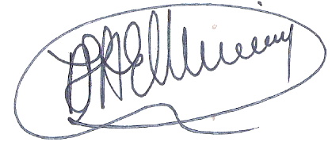
____________________

After the registration has been submitted the data entered will be checked by the editorial team of CommunityGuide Aruba before the organization listing appears on the website.

Please send the completed form to info@org.aw
Thank you for your cooperation

